Civil war in Sierra Leone

UNSC Resolution: | 1162
Date of adoption: | 17 April 1998
Operative paragraph: | 3
Demand number: | 1

Megan MacKenzie

Wording of demand

promote national reconciliation in Sierra Leone, work towards this objective

List of addressees of the demand

Government of Sierra Leone, Armed Forces Revolutionary Council, Kamajors, Revolutionary United Front

Short-term compliance

Description of the addressee(s)’ conduct

Leaders of Sierra Leone's ousted junta have written a letter to United Nations Secretary-General Kofi Annan, blaming ECOMOG for recent atrocities against civilians but seeking an end to the fighting. U.N. officials in Freetown told the Integrated Regional Information Network for West Africa (IRIN) that the letter, which was sent to their office and was also published in the local newspaper Punch, appeared to be authentic. It was dated May 10, but apparently only reached Freetown in recent days, U.N. officials said.
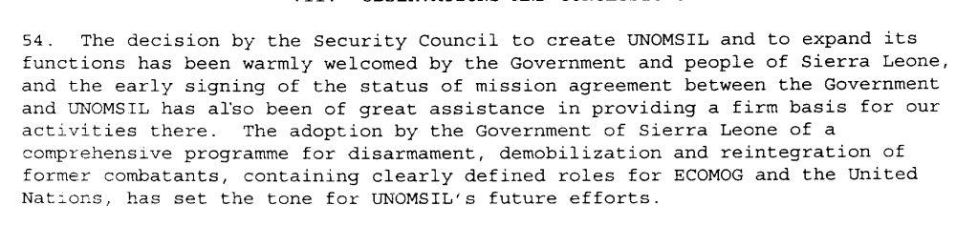

Assessment

Short-term compliance
No or marginal compliance (1) | Medium low compliance (2) | x Medium high compliance (3) | Full or almost full compliance (4)

Considerations underlying the assessment

The demand asks for the promotion of peace and reconciliation and in the short term, it seems that the parties made an effort to comply. There is not much indication of the Kamajors’ response to this demand.

Medium-term compliance

Description of the addressee(s)’ conduct

December 1998
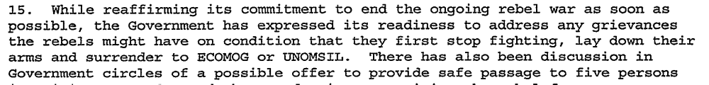
January 1999
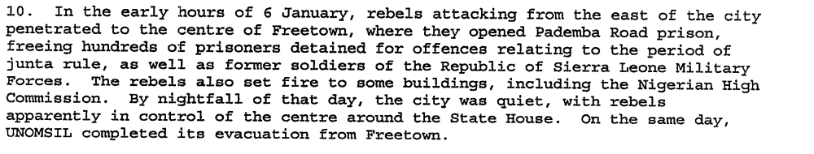
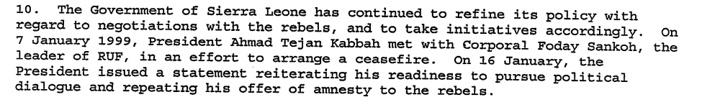
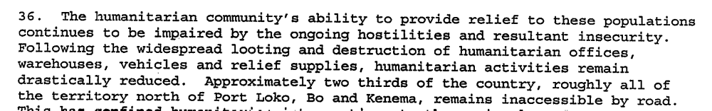

Assessment

Medium-term compliance
x No or marginal compliance (1) | Medium low compliance (2) | Medium high compliance (3) | Full or almost full compliance (4)

Considerations underlying the assessment
The Government of Sierra Leone made clear efforts to work towards peace and reconciliation during this period. Overall, these two years were some of the most violent in the country’s history and were marked by brutally and human rights abuses.

Depth of demand

Assessment

Level of depth of demand
Low depth of demand (1) | x Medium depth of demand (2) | High depth of demand (3)

Considerations underlying the assessment
Promoting peace and reconciliation is a medium depth demand primarily because of the verb ‘promoting.’ The parties could promote peace and reconciliation- at least at a basic level- without completely altering their own behaviors.

Level of confidence about coding decisions

Level of confidence about coding decision
Extremely high | x High | Moderate

Comments to IPI (if any)

Sierra Leone Web. Sierra Leone News June 1998. 30 June 1998. http://www.sierra-leone.org/Archives/slnews0698.html (retrieved 26 August 2009)
United Nations Secretary General. First Progress Report of the Secretary General on UNOMSIL. 12 August 1998.

